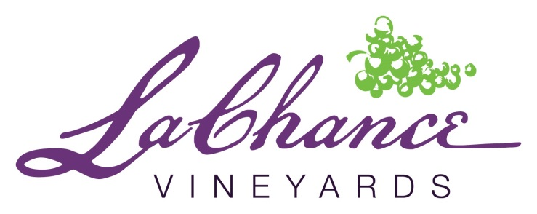
LUNCH SERVED FROM 11AM – 4PM

Starters

- Spinach Artichoke Dip $4.99/$8.99
- Loaded Potato Wedges $4.99
- Crispy Shrimp (3) $6.99

Flat Breads

Vegetable $7.99
- Roasted tomato sauce, zucchini, caramelized onions, tomatoes, mushrooms, mozzarella cheese.
Meat $8.99
- Fire roasted tomato sauce with house blend sausage, pepperoni, and bacon with mozzarella cheese.
Shrimp $9.99
- Roasted garlic, olive oil, and butter sauce blend with pineapple,
and shrimp with mozzarella cheese.

Salads
Farm $5.99
- Iceberg and Romaine mix, tomatoes, red onions, and cucumber. Served with Buttermilk Dressing.
Caesar $6.99
- Romaine lettuce, house made croutons, and parmesan cheese. Served with our LaChance Caesar dressing.
Spring $6.99
- Spring mix with strawberries, goat cheese, dried sour cherries, and candied pecans with balsamic dressing

- Add a cup of soup with salad for $2.49
- Add chicken to salad for $1.99
Soup of the Day $5.99

Sandwiches
*All sandwiches served with your choice of potato wedges or our house made chips*
*Substitute potato wedges or chips with a side salad for an additional $1*

Henry Farms Brat $4.99
- With cole slaw and our Old Depot Mustard
Chicken Salad $8.99
- Diced grilled chicken with onions, celery, grapes, candied pecans, served on a croissant.
LaChance Burger $9.99
- An 8oz burger seasoned with our LaChance seasoning. Topped with cheddar
Cheese, lettuce, tomato, onion, and our house made pickles, served on a fresh bun.
Fish & Chips $9.99
- Fried Cod with cole slaw and caper Tatar sauce.

Ask About our Daily Specials

